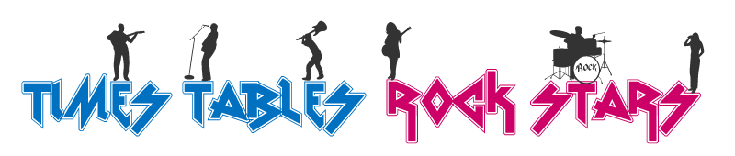
When it comes to times tables, speed AND accuracy are important – the more facts your child remembers, the easier it is for them to do harder calculations.
Times Table Rock Stars is a programme designed to help children master the times tables!
World famous rock musicians are the best at what they do because they've spent hours practising guitar chords, writing music or playing on the drums. It's just the same with times tables – all Times Table Rock Stars need to practise and practise and practise.
It's essential that your child does a little bit of times table practice regularly. Short bursts of daily practise are more effective than spending hours once a week.
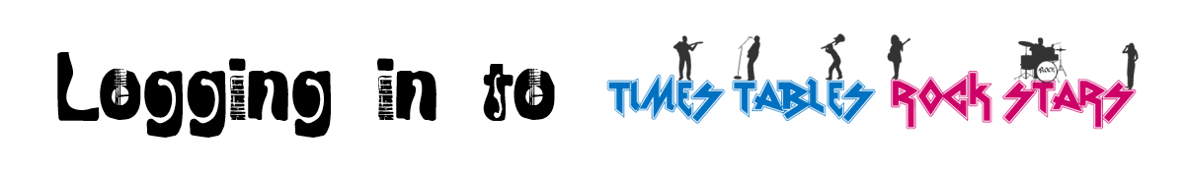
- Type ttrockstars.com into your browser’s address bar or download the App.
- Log in. Your child will have been given their login details from their teacher.
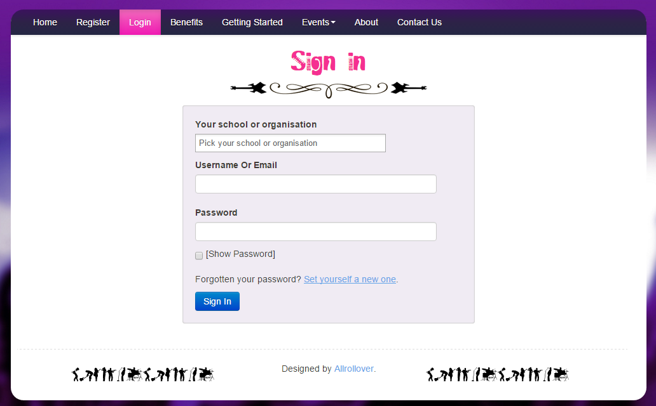
Password goes here
Username goes here
School goes here

- Play! There are 4 different game modes, which you can find out about on the back.

Game Modes
Single Player

Garage - the questions will only come from the times tables the teacher has set for the week. As pupils start to answer questions, TT Rock Stars works out which facts they take longer on and will give them more of these questions to answer. The Garage is best for getting quicker at a few facts. Players get 10 coins per question.

Studio - the questions in the Studio can be anything from 1×1 up to 12×12.
TT Rock Stars calculates each the mean speed from their last 10 games in the Studio and translates into a Rock Status:
≤ 1 sec/qu = Rock Hero  ≤ 2 secs/qu = Rock Legend  ≤ 3 secs/qu = Rock Star  ≤ 4 secs = Headliner  ≤ 5 secs/qu = Support Act  ≤ 6 secs/qu = Breakthrough Artist | ≤ 7 secs/qu = Unsigned Act  ≤ 8 secs/qu = Gigger  ≤ 9 secs/qu = Busker  ≤ 10 secs/qu = Garage Rocker  > 10 secs/qu = Wannabe
They earn 1 coin per question and the Studio is the place for them to set their best time across all the tables.
Multiplayer

Rock Arena - The Arena allows players to compete against all other members of their Band (their Bandmates would need to join the same game in order to compete together).
A new Arena game starts every 15 seconds and once the clock starts they race to answer more questions than the others. In the Arena, questions will only come from the times tables the teacher has set for the week, similar to the Garage. They earn 1 coin per correct answer.

Rock Festival - The Rock Festival games are open to players from around the world. Like the Arena, there is no limit to the number of players who can join a game; however, unlike the Arena, questions are selected at random from 1×1 to 12×12.
Pupils might choose the Rock Festival if they were playing at home (and therefore couldn't easily synchronise playing against a classmate) or wanted to compete against others not in their Band. They earn 1 coin per correct answer.

